a) Standard deviation and standard error formulae are integrated to TestGroup_D.cpp.

b) Batch 1 and 2’s SD and SE are charted below with different combinations of (NT, NSIM).

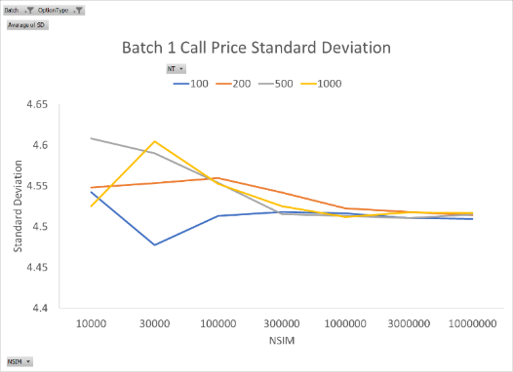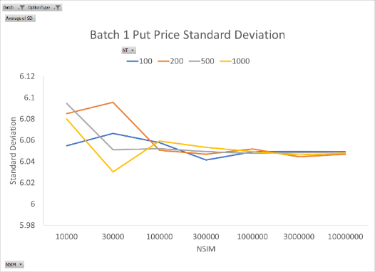

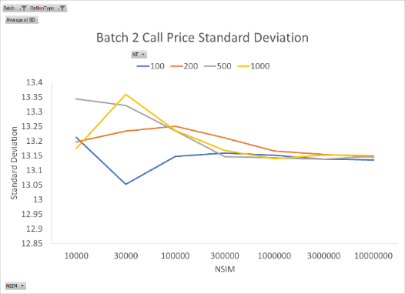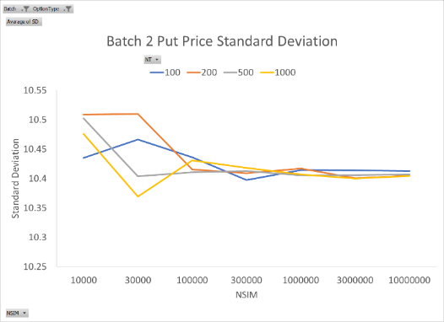

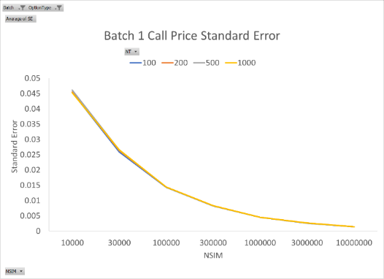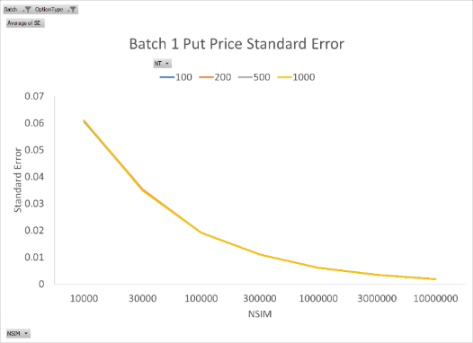

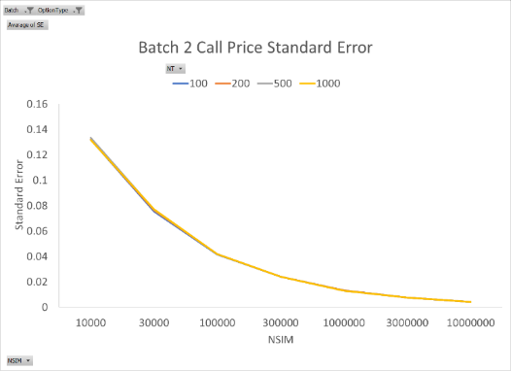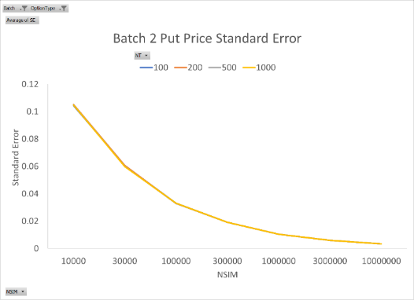

SD stays around the same level as NSIM increases. However, as NSIM increases, SD of different NT all converge to the same value, which means precision of SD increases. SE decreases in a very smooth manner as NSIM increases. This makes sense since accuracy of MC seems to increase along with NSIM.